VISVESVARAYA TECHNOLOGICAL UNIVERSITY BELGAUM


A MINI-PROJECT REPORT ON
Smart blind stick
Submitted by:
Mohammed bathish ks(Leader)
Muhammad Ifaaz Beig B
Mohammed Affan Ahamed
Mohammed Fouzan
Pavan.R

Under the Guidance of:
Prof. VITTAL BHAT M
(Asst. Professor, Department of ECE)

DEPARTMENT OF ELECTRONICS & COMMUNICATION ENGINEERING
P. A. COLLEGE OF ENGINEERING
Nadupadavu, Mangaluru – 574153, D. K. KARNATAKA 2024 – 2025

TABLE OF CONTENTS

Sl. No. | Title | Page No.
1. | INTRODUCTION | 3
2. | HARDWARE & SOFTWARE REQUIREMENTS | 4-10
3. | METHODOLOGY | 11-12
4. | RESULTS & DISCUSSIONS | 13
5. | CONCLUSION | 14

INTRODUCTION:
A smart blind stick using an Arduino Uno, ultrasonic sensor, and buzzer is a simple yet effective assistive device for individuals with visual impairments. The ultrasonic sensor detects obstacles in the user's path by emitting sound waves and measuring the time it takes for them to bounce back. When an obstacle is detected, the sensor sends a signal to the Arduino Uno, which activates the buzzer to alert the user. The frequency and intensity of the buzzer's sound can vary depending on the proximity of the obstacle, allowing the user to adjust their movements and navigate more safely. This low-cost solution offers a practical way to improve mobility for visually impaired individuals with minimal complexity
These are the uses of smart blind stick:
1. Obstacle Detection:
Ultrasonic Sensors: Detect nearby objects or obstacles and alert the user through vibrations or sound signals, helping to navigate safely.
2. Enhanced Mobility:
Allows visually impaired individuals to move independently by identifying objects or hazards in their path, such as walls, furniture, or people.
3. Distance Measurement:
The ultrasonic sensor can measure the distance of objects and provide feedback, enabling users to understand their surroundings better.
4. Safety and Awareness:
Alerts users about immediate dangers such as steps, stairs, or uneven surfaces, reducing the risk of trips and falls.
5. Lightweight and Portable:
The design makes it easy to carry, offering convenience for daily use.
6. Customizable Alerts:
Feedback mechanisms like vibrations, sounds, or LEDs can be adapted to suit the user's needs.

GXG
2

2.Hardware and software requirements

1.1 Hardware components:
(a) Arduino UNO
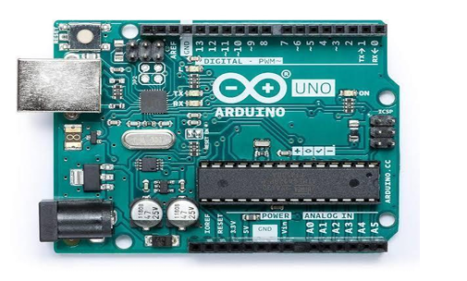
Fig. 1.1.1 Arduino Uno board
Arduino / Genuine Uno is a microcontroller board based on ATmega328P(datasheet).It has 14 digital input/output pins(of which 6 are used as PWM outputs),6 analog inputs, a 16 MHz quartz crystal a USB connection, a power jack, an ICSP header and a reset button. It contains everything needed to support the microcontroller; simply connect it to a computer with a USB cable or power it with a AC-to-DC adapter or battery to get started .You can tinker with your UNO without worrying too much about doing something wrong, worst case scenario you can replace the chip for a few dollars and start over again.

(b) Ultrasonic sensor
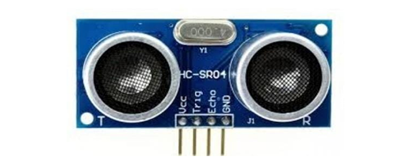
Fig. 1.1.2 Ultrasonic sensor
An ultrasonic sensor is an electronic device that measures the distance of a target object by emitting ultrasonic sound waves, and converts the reflected sound into an electrical signal. Ultrasonic waves travel faster than the speed of audible sound (i.e. the sound that humans can hear). Ultrasonic sensors have two main components: the transmitter (which emits the sound using piezoelectric crystals) and the receiver (which encounters the sound after it has travelled to and from the target)

(c) Buzzer
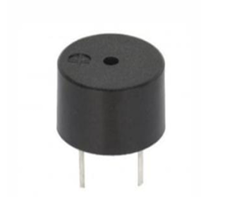
Fig. 1.1.3 Buzzer
A buzzer is an electromechanical device that produces sound or an audible signal when an electrical current passes through it. It typically consists of a housing, an electromagnet, and a vibrating element, like a diaphragm or a piezoelectric element. When the current flows through the coil of the electromagnet, it generates a magnetic field, causing the vibrating element to move back and forth rapidly, creating sound waves. Buzzers are used in various applications such as alarms, notifications, timers, and in electronic circuits to indicate certain conditions or events due to their simplicity, cost-effectiveness, and ease of use.
(d) Jumper wires

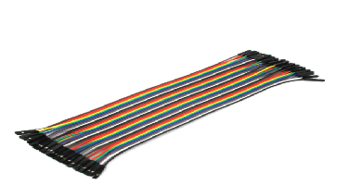
Fig. 1.1.4 jumper wires
Jumper wires are essen al components in electronics and prototyping. These wires, typically made of insulated metal, come in various lengths, colors, and connectors.
(e) 9V Battery
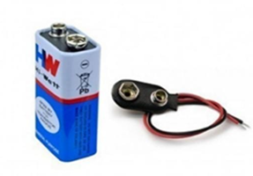
Fig. 1.1.5 9V Battery
A power supply is an electrical device that supplies electric power to an electrical load.

(f) LED(Light Emitting Diode)
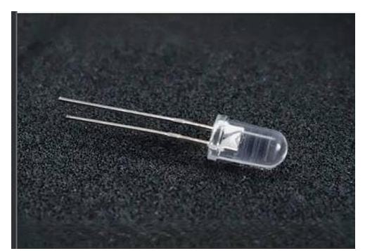
Fig 1.1.6 LED
Light Emitting Diodes (LEDs) are semiconductor devices that emit light when an electric current passes through them.
Software requirements

(a)Arduino IDE software
The Arduino IDE is an open-source software, which is used to write and upload code to the Arduino boards. The IDE application is suitable for different operating systems such as Windows, Mac OS X, and Linux. It supports the programming languages C and C++. Here, IDE stands for Integrated
Development Environment. The program or code written in the Arduino IDE is often called as sketching. We need to connect the Genuino and Arduino board with the IDE to upload the sketch written in the Arduino IDE software. The sketch is saved with the extension ‘. ino’

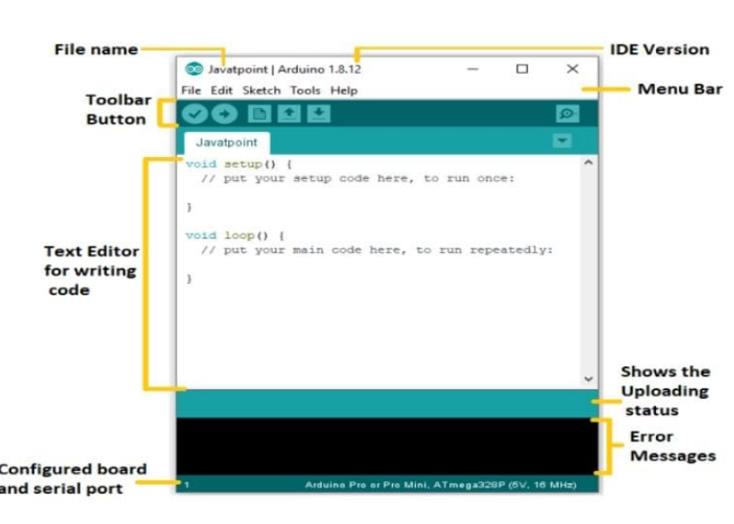

Fig. 1.2.1 Arduino software tool

4. SOFTWARE DESCRIPTION

Source Code:
The code for the project Smart Guide Cane using Arduino is given below
// defines pins numbers
const int trigPin = 9;
const int echoPin = 10;
const int buzzer = 11;
const int ledPin = 13;

// defines variables
long duration;
int distance;
int safetyDistance;

void setup() {
pinMode(trigPin, OUTPUT); // Sets the trigPin as an Output
pinMode(echoPin, INPUT); // Sets the echoPin as an Input
pinMode(buzzer, OUTPUT);
pinMode(ledPin, OUTPUT);
Serial.begin(9600); // Starts the serial communication
}

void loop() {
// Clears the trigPin
digitalWrite(trigPin, LOW);
delayMicroseconds(2);

// Sets the trigPin on HIGH state for 10 micro seconds
digitalWrite(trigPin, HIGH)
; delayMicroseconds(10);
digitalWrite(trigPin, LOW);
// Reads the echoPin, returns the sound wave travel time in microseconds
duration = pulseIn(echoPin, HIGH);

// Calculating the distance
distance= duration*0.034/2;
safetyDistance = distance;
if (safetyDistance <= 5){
digitalWrite(buzzer, HIGH);
digitalWrite(ledPin, HIGH);
}
else{
digitalWrite(buzzer, LOW);
digitalWrite(ledPin, LOW);
}
// Prints the distance on the Serial Monitor
Serial.print("Distance: ");
Serial.println(distance);
}

3. METHODOLOGY
1 Hardware Description:
The below block diagram represents the working of the smart blind stick.
When the circuit is given a power supply, the ultrasonic sensor sends sound signals and whenever an obstacle is detected, a signal is sent to the buzzer and the buzzer alarms indicating the presence of an obstacle.

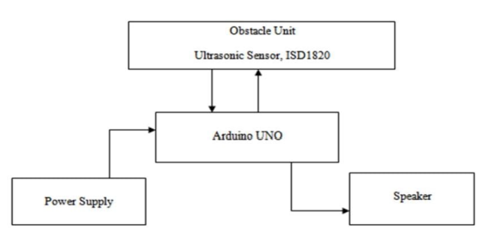
Fig. 2.1 Block diagram
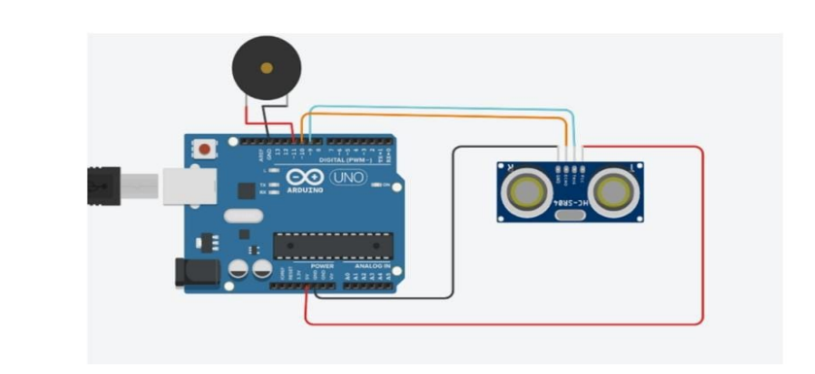
Fig. 2.2: circuit diagram
The above figure represents the circuit diagram of the smart blind stick.
The trig pin and echo pin of the ultrasonic sensors are connected to pins 9 and 10 of the Arduino board respectively. Gnd pin of ultrasonic sensor is connected to gnd pin of Arduino board and Vcc to 5V. The positive end of the buzzer is connected to pin 11 of the Arduino board and negative end is connected to gnd pin.

5. RESULT & DISCUSSION

1. Snapshot of the Project:
The circuit is connected according to the block diagram and circuit diagram. The code is uploaded to the arduino board using an USB cable.
Then a high voltage power is supplied to the circuit using a 9V battery.

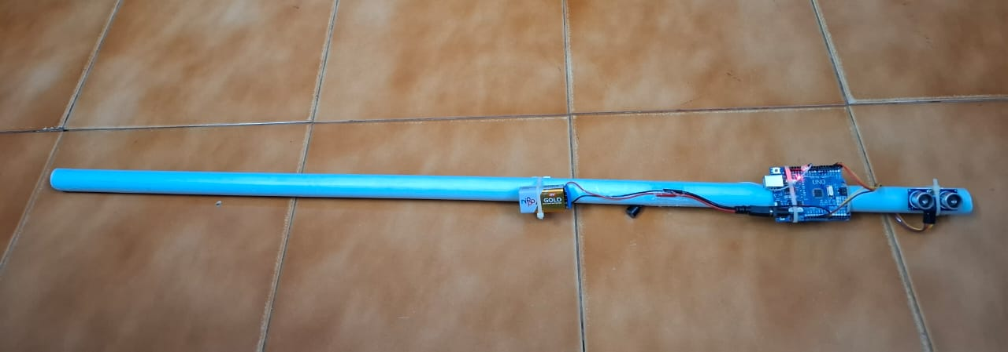

2.Result:
The smart blind stick has been a remarkable innovation in assisting individuals with visual impairments to navigate their surroundings more independently and safely. It incorporates various sensors and technologies such as ultrasonic sensors, cameras, and sometimes even AI algorithms to detect obstacles, drop-offs, or objects in the user's path. These sensors relay information to the user through haptic feedback, sound alerts, or vibrations, providing real-time environmental feedback. Additionally, some smart blind sticks can connect to smartphones or other devices, allowing users to receive more detailed information or navigate with greater precisionn. Overall, the smart blind stick has significantly contributed to enhancing the mobility and autonomy of visually impaired individuals, enabling them to move around with increased confidence and ease.

6. CONCLUSION

It should be noted at this stage that this work has been thoroughly carried out in order to design and implement an articulate walking bolt for the blind. The smart stick acts as a versatile interface for easy and comfortable internal and external mobility for visually impaired people in the next phase of more supportive apps. It’s safe and affordable. This results in effective obstacle detection within three meters of the user’s direction. It offers low cost, reliable, lightweight, low power and efficient navigation with fast, quick response times. The computer is hardwired, but light weight, with sensors and other features. Wireless connectivity between components of the device will enhance the additional features of this instrument and increase the range of ultrasound sensors and incorporate technologies to measure the intensity of obstacles approaching. With this approach, our targets in all of the developing countries were particularly addressed towards visually impaired and blind people. In this analysis the machine built can only sense obstacles.

